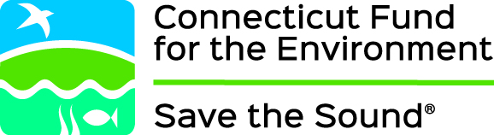

FOR IMMEDIATE RELEASE
November 4, 2016

Contact:
Laura McMillan 540-292-8429
Melissa Schlag 860-398-0569

Siting Council okays CFE involvement in Killingly gas plant application

NEW HAVEN, CONN. – At a Connecticut Siting Council hearing yesterday, Connecticut Fund for the Environment’s request for party status was granted in an application for a new natural gas-powered electric generating plant in Killingly, Conn.

Sierra Club and the Wyndham Land Trust were also granted party status.

NTE Connecticut, LLC is seeking approval to build a new natural gas powered electric generating plant in Killingly, to be known as the Killingly Energy Center. CFE contends the application is incomplete and misleadingly minimizes the environmental impacts.

CFE and Not Another Power Plant (NAPP) also filed motions to dismiss the NTE application, asserting the application was incomplete due to improper segmentation that minimizes adverse environmental impacts of the entire project. The motions to dismiss were denied.

“We are disappointed with the Siting Council’s denial of the motions to dismiss,” said CFE Staff Attorney Jack Looney. “CFE will continue to oppose the construction of this gas facility in Killingly because of its potential adverse impacts to the air quality and open space of Northeast Connecticut.”

###

